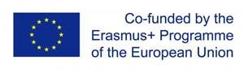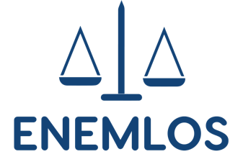

ENHANCING THE EMPLOYABILITY OF LAW STUDENTS THROUGH PRACTICAL EDUCATION ENEMLOS
Programme of the three-day online training organised by the Regent’s University London

29 November 2021 – 1 December 2021
(ALL TIMES ARE EUROPEAN, i.e., The Hague, Podgorica, Pristina, Berlin)

Monday 29 November

1000: Neven Andjelic: Introduction

1030: Mark Allinson:
Developing a university pedagogy and learning design framework: the transformative power of the pandemic

1230: Lunch Break

1415: Damian Bielicki: Law Clinics in British Higher Education

1530: The End

Tuesday 30 November:

1000: Vanja Skoric, Andrea Judit Toth:
Creating a Space for Active Civic Engagement, Empowering Civil Society”

1130: Lunch Break
1300: The work of the AIRE Centre in the Western Balkans, Strasbourg and UK
1300: Catharina Harby
1330: Catharina Harby and Biljana Brathwaite
1430: Coffee Break
1530: Nuala Mole
1630: Hannah Smith
1730: The End

Wednesday 1 December:

1000: Caroline Varin: Professors Without Borders

1200: Lunch Break

1330: Marius Calu: International Researchers and the Western Balkans

1500: Neven Andjelic: Closing Remarks
1530: The End

